Advanced Placement Environmental Science Summer Assignment

Dear Students,

Welcome to AP Environmental Science! **Students who enroll in AP Environmental Science should be ready and willing to devote sufficient time, focus & energy to class assignments, taking notes in and outside of class, preparing for frequent exams and quizzes, participating in laboratory and field experiments, writing reports, participating in class discussions and doing other various class assignments.** Students who are not able or willing to devote sufficient time, focus and energy to this course should consider taking it at another time.

The major topics of the class we will be covering this year are as follows:

* Energy Systems and Resources – *Atmosphere, Soil, Groundwater, and Geology*
* The Living World – *Ecosystems and Biogeochemical Cycles*
* Populations – *Demographics, Dynamics and Growth*
* Land and Water Use – *Agriculture, Forestry, Mining, Fishing and Global Economics*
* Energy Resources and Consumption- *Fossil Fuels, Nuclear Energy, Conservation and Consumption*
* Pollution – *Types of Pollution and their Impacts, Waste Disposal*
* Global Change – *Ozone, Global Warming, Loss of Biodiversity*

To be better prepared, we need to do some work over the summer. The purpose of this summer assignment is to get you thinking about the environment in which we live and help prepare you for your studies in environmental science for the upcoming school year. You should plan on immersing yourself in the subject of environmental science for the next year.

All parts of this assignment that require turning in on **CANVAS** can be submitted on a summer page that has been created (**2** in total, **3** if you do notecards digitally, see due dates below) – Work can be submitted digitally or printed and photos taken/uploaded

**Assignment Overview and Checklist**

* 1. **“Home” Movie and Movie Questions** (Due 7/21 – submitted to **Canvas**)
  2. **Environmental Geography** – (Due 8/11 – submitted to **Canvas, QUIZ** second week of class)
  3. **Law Review Notecards** (shown to teacher in class, or submitted to **Canvas**, first week of school – **QUIZ** second week of class)
  4. **Prerequisite Knowledge and Skills** – nothing to be turned in for this portion but you must review and brush up on your science and math skills and I will be available for help during the first week of school.

I am excited to embark on this challenging journey together and look forward to meeting each of you. If you have questions at any point, please don’t hesitate to ask.

Thanks,

Mr. Wasnesky

ewasnesky@manasquan.k12.nj.us

# Assignment #1: Watch “Home” and answer questions (Due 7/21 – submitted to Canvas)

Movie Link: <https://www.youtube.com/watch?v=ghkQoJoipbM>

Create a Word file where you can copy/paste in the questions below then answer the questions thoughtfully and completely.

# APES: “Home” Movie Questions

1. Describe the conditions on early Earth.

1. What happened to the carbon that poisoned the atmosphere?

1. How did the agricultural revolution change the Earth?

1. How has Earth changed in the last 60 years since the use of oil has become more widespread?

1. What is most of the grain in the US used for?

1. What led to the dramatic decline in the biodiversity of agricultural crop species?

1. How many kilos of water does it take to produce 1 kilo of beef?

1. How have cars shaped the way housing is laid out in the US and other developed countries?
2. How much has the volume of international trade increased since 1950?

1. What are your thoughts on how the video portrays Dubai? Is it self-sustainable?

1. Rainforests are cut down to make farmland for which products/crops?

1. What makes the growth of Lagos different from how most other cities grow?

1. Where does the water from Greenland’s melting ice sheet go?

1. Why are the glaciers of mountains so important for the people in the lowlands?

1. What hope does the video offer at the end?

# A picture containing text, screenshot, design Description automatically generatedAssignment #2: Environmental Geography – (Due 8/11 – submitted to Canvas, QUIZ second week of class)

**Part I**

**Directions** Fill in the blanks using the word bank. Then on the Part I map, **NAME and label the location of each**. This can be done using the “Draw” tool in Word to mark up the map (see right) or print and take photos to upload.

Love Canal Yucca Mountain Cuyahoga Fukushima  
Montreal BP Deepwater Horizon Grand Banks/Newfoundland Bhopal   
Kyoto Fresh Kills ANWR Dust Bowl  
Chernobyl Three Gorges Arctic/N. Pole Flint, MI Japan Animas River Antarctica Aliso Canyon

* Site of the largest nuclear disaster in the world. ____________________________________________________
* Site of agriculture degradation due to drought and winds in the 1930s. _____________________________________________
* Site of a toxic gas from a pesticide factory (Union Carbide) that killed thousands. _______________________________________
* Site of Asian Tsunami and nuclear disaster. ________________________________________________________________
* Site of the largest oil spill in history. ____________________________________________________________
* Site of treaty that banned CFCs. _____________________________________________________________________
* Site of treaty to reduce GHGs. ___________________________________________________________________________
* Site of a river that caught on fire repeatedly and prompted the passage of the Clean Water Act. ________________________
* Site of a capped landfill that is being turned into a park in NY. _____________________________________________________
* Site of a neighborhood in the US where families were evacuated due to toxic chemicals. ___________________________________
* Site of the proposed long-term storage of nuclear waste in the US. ___________________________________________________
* Site of the controversial oil drilling location in Alaska. ____________________________________________________________
* Site of the largest dam in the world. ___________________________________________________________________
* Site of the largest fishery collapse in the world. ________________________________________________________________
* This region of the world is currently experiencing the largest annual temperature increase because of anthropogenic climate change: ___________________________________________
* Site of the river that was contaminated in Colorado due to a spill from a superfund mine cleanup _________________________
* Site of major lead poisoning in the city’s water supply ____________________________________
* Site in CA of the largest methane leak in history ___________________________________________________
* Island nation with the highest population density _______________________________________

**Part II  
Directions** Fill in the blanks using the word bank. Then on the Part II map, **NAME and label the location of each**.

Yellowstone Great Lakes New Zealand Arctic/N. Pole  
London Three Mile Island Antarctica Prince William Sound, Alaska  
Gulf of Mexico Maldives Arctic Prairie (Midwest of US)   
East Coast of the US Mexico Minimata Bay Paris  
Great Barrier Reef Brazil California

* Site where Global Distillation sends POPs such as PCB and DDT. ____________________________________________
* Site where Zebra Mussels first entered the U.S. _________________________________________________
* Country where transgenic maize contaminated from U.S. crops was found. ________________________________
* Site of the most infamous “Dead Zone” in US waters. ___________________________________________________
* Site of 1952 inversion layer that killed thousands. ______________________________________________
* Country that may disappear if sea levels rise due to climate change. ___________________________________
* Region/Biome where large quantities of methane hydrates are located and if released will contribute significantly to climate change.________________________________________________
* Region/biome in the US that has the most tornados. ______________________________________
* Site of most ozone thinning. _________________________________________________________________________
* State with the San Andreas Fault. ____________________________________________________________________
* Site of the Exxon Valdez spill-the 2nd worst oil spill in the ocean. ______________________________________________________
* Site of a bay where thousands died from mercury poisoning. _______________________________________________________
* Site of the world’s first National Park. ___________________________________________________________
* Region in the US that experienced Hurricane Sandy in 2012 _______________________________________
* Site of nuclear melt-down in the US. ______________________________________________________________
* Site of the 2015 Climate agreement ____________________________________________________________
* Largest coral reef in the world that is also dying ___________________________________________
* Country which held the 2016 Summer Olympics and where the Zika Virus was spreading _________________________________
* Island Nation with the most UV exposure (due to its proximity to Antarctic) ___________________________________

**Part I Map**

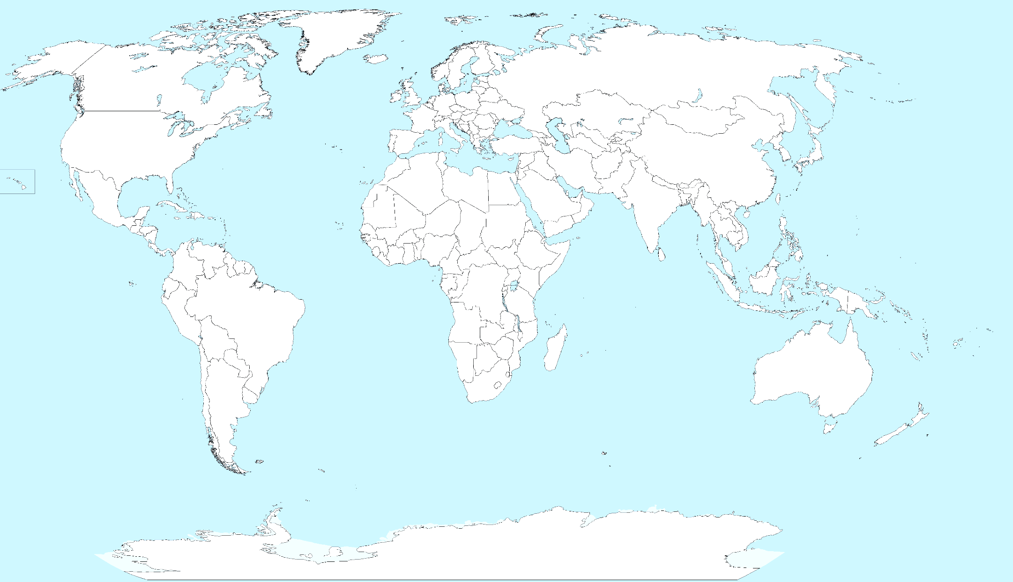

**Part II Map**



# Assignment #3: Law Notecards (shown to teacher during first week of school, QUIZ second week)

Find the following for each of the laws and/or treaties listed below and put on a notecard. You will be quizzed on these laws throughout the school year so coming into the course with these already done will be VERY helpful. I will be checking to see that you have these notecards completed on the first day of class. Can be typed, handwritten or digital if you prefer to use something like Quizlet (YOU must have created them though and have emailed a link to teacher during the first week of school).

a) Draft Year, International or National

b) Description of Function; Environmental Issues Affected

c) Agency/Group Responsible for Regulation and Enforcement (i.e. United Nations, Department of Interior, EPA, etc.)

**Laws to be covered:**

|  |  |  |
| --- | --- | --- |
| Clean Air Act | National Park Act | Convention on International Trade in Endangered Species |
| Clean Water Acts | Kyoto Protocol | Oil Pollution Act |
| Endangered Species Act | Montreal Protocol | Safe Drinking Water Act |
| Soil and Water Conservation Act | Fish and Wildlife Conservation Act | Wilderness Act |

# ***The rest of this is information for you to be familiar with, not an assignment***

# 4. Prerequisite Knowledge and Skills

You are expected to enter the course with a good understanding of basic scientific and mathematical concepts and skills as well as strong, reading and writing abilities. Although we will continue to develop these skills throughout the class, your success is also dependent upon what you bring to it at the onset. Over the summer, review the scientific concepts and mathematical calculations below. We will be building upon and referencing them throughout the year.

**Part A: Prerequisite Basic Scientific Concepts:** You should be familiar with the following terms/concepts from your previous science courses.

|  |  |  |
| --- | --- | --- |
| Organic vs. Inorganic  Natural vs. Synthetic  Kinetic vs. Potential Energy  Radioactive decay  Half life  Law of Conservation of Matter  1st Law of Thermodynamics  2nd Law of Thermodynamics  Entropy  Organism  Species  Population | Community  Ecosystem  Producers/Autotrophs  Consumers/Heterotrophs  Decomposers  Photosynthesis (reactants and products)  Cellular Respiration (reactants and products)  Aerobic vs. Anaerobic  Adaptation  Mutation | Gene  Trait  Chromosome  Gene pool  Natural Selection  Biodiversity  Extinction  Plate Tectonics  Weathering  Climate Change  Rocks vs. Minerals  Climate vs. Weather |

You will also need to know the full name of each of these chemical abbreviations:

CO2, CO, C6H12O6, CH4, H2, H2O, N2, NOX, NO3-, NH3, 02, 03, P, P043-, S, S02, Cl, K, NaCl, Pb, Hg, U

**Part B: Prerequisite Basic Mathematical Skills**

You should also be prepared to perform mathematical calculations like found below. Sometimes these calculations are fairly simple and you can complete the problems in your head (the use of calculators is expected on the AP exam). However, the APES exam requires that you SHOW ALL WORK for credit for the calculations on the free-response questions.

**Percentage**

17% = 17/100 = 0.17

* Remember that "percent" literally means divided by 100.
* Percentage is a measure of the part of the whole. Or part divided by whole. o 15 million is what percentage of the US population? 15 million / 300 million = .05 = 5% o What is 20% of this $15 bill so that I can give a good tip? $15 x .20 = $15 x 20/100 = $3

**Rates**

|  |  |
| --- | --- |
| Rise Y2-Y1 | slope change y=mx+b dX |
| Run X2-X1 | time dt |

All of the above are ways to look at rates. The second equation is the easiest way to calculate a rate, especially from looking at a graph. Rates will often be written using the word "per" followed by a unit of time, such as cases per year, grams per minute or mile per hour. The word per means to divide, so miles per gallon is actually the number miles driven divided by one gallon. Rates are calculating how much an amount changes in a given amount of time.

**Scientific Notation**

Thousand = 103 =1,000

Million = 106 =1,000,000 (people in the US)

Billion = 109 =1,000,000,000 (people on Earth)

Trillion = 1012 =1,000,000,000,000 (National debt)

* When using very large numbers, scientific method is often easiest to manipulate. For example, the US population is 300 million people or 300 x l06or 3 x l08
* When adding or subtracting, exponents must be the same. Add the numbers in front of the ten and keep the exponent the same.
* When multiplying or dividing, multiply or divide the number in front of the ten and add the exponents if multiplying or subtract the exponents if dividing

Ex. 9xl06/ 3xl02 = (9/3) x 10(6-2) = 3 x 104

**Dimensional Analysis**

You should be able to convert any unit into any other unit accurately if given the conversion factor. Online tutorials are available:

<http://chemprofessor.com/class-notes/dimensional-analysis/>

<http://www.chem.tamu.edu/class/fyp/mathrev/mr-da.html>

**Prefixes**

m (milli) =1/1000  =10-3

c (cent) =1/100 = 10'-2

k (kilo) =1000 =103

M (mega) =1,000,000 =106

G (giga) =1,000,000,000 =109

T (tera) =1,000,000,000,000 =1012

**Scientific Notation**

Practice by writing the following numbers in scientific notation:

* 1. One million
  2. Forty-eight thousand
  3. 5878300
  4. 0.015

Convert the following to regular notation:

1. 2.45 x 104
2. 9.1 x 102
3. 7.5469 x 104
4. 1.970 x 105
5. 8 x 101

Use Scientific Notation (and only Scientific Notation) solve the following problems:

1. (6.235 x 10-8)x(6.7 x 102) =
2. (2.456 x 104)¡À(1.436 x 1013)=
3. (2.34 x 10-6)x(3.3 x 104)=

How many significant figures are in the following numbers? What rule(s) did you use to determine the number?

1. 30
2. 0.4
3. 9050
4. 0.078
5. 0.007040
6. 1.7 x 106

Solve the following using the correct number of significant figures:

1. ( 3.682445 x 10-1)x(1.13964 x 106)
2. 4.0001 x 6
3. (1.12 x 105)x(6.05 x 105)

Dimensional Analysis

1. 8,640 mm -> cm
2. 175 lbs -> kg
3. 33.2 kg/L -> kg/mL
4. 3.8 Km/sec -> miles /year
5. A 100 square mile area of National Park is how many acres? How many hectares?
6. A factory using four million BTUs of energy each month is using how many kilowatt-hours of energy?
7. The total amount of freshwater on earth is estimated to be 3.73 x 108 km3. What is the volume in cubic meters? In liters?

Percentages

1. If 35% of a natural area is to be developed, leaving 500 acres untouched, how many acres are to be developed?
2. If the concentration of mercury in a water supply changes from 65 ppm to 7 ppm in a ten-year period, what is the percentage change of the mercury concentration?
3. Fifteen million is what percentage of the U.S. population of 300 million?

Sample Math Problems (not required work, but be prepared for similar problems)

Be sure you are able to complete the following types of problems.

1. What is one million times one thousand? Show your work in scientific notation. Give the answer in scientific notation and in words.
2. A population of deer had 200 individuals. If the population grows by 15% in one year, how many deer will there be the next year?
3. Electricity costs 6 cents per kilowatt hour. In one month a home uses one megawatt hour of electricity. How much will the electric bill be? (be sure to look at the prefixes chart on the previous page for the conversion of kilo to mega)
4. Virginia Beach is 10 miles wide and 30 miles long. If one inch of rain falls on Virginia Beach, how many cubic feet of rain fell on Virginia Beach. (Hint: convert all units to feet first).